

**NATIONAL ECONOMIC CONSULTATIVE FORUM**

**MONTHLY ECONOMIC BULLETIN**

**31 JULY 2024**

# Executive Summary

This bulletin focuses on economic developments for the month ending 31 July 2024 that include: World economic developments, international commodity prices, Zimbabwe Gross Domestic Product (GDP) growth updates, merchandise trade developments, exchange rate developments, inflation developments, monetary developments and stock market developments.

The global economy is projected to experience a slight decline in growth from 3.3% in 2023 to 3.2% in 2024, according to the International Monetary Fund (IMF) July 2024 World Economic Outlook Update. Persistent geopolitical conflicts and the El Niño drought effects contribute to this slowdown. The outlook for 2025 anticipates a marginal recovery to 3.3% growth. Advanced economies, such as the United States and the Euro Area, exhibit mixed performance, with the U.S. expected to decelerate to 1.9% growth in 2025, while the Euro Area shows signs of improvement. Emerging markets and developing economies are projected to experience a slight decline in growth, with Sub-Saharan Africa seeing modest gains driven by Nigeria and South Africa.

Global inflation remains a challenge, with service sector inflation complicating efforts to normalize monetary policy. Advanced economies are expected to see a slow pace of disinflation in 2024 and 2025, while emerging markets will continue to face high inflation.

International commodity prices showed a negative trend, with gold and cotton as exceptions, which gained by 5.13% and 7.01%, respectively, on a month-on-month basis. However, overall commodity prices fell due to the global economic slowdown, which has reduced demand for energy, mineral, and agricultural products.

In Zimbabwe, economic growth is projected at 2% in 2024, down from earlier projections of 3.5%. The decline is attributed to the El Niño-induced drought, low international commodity prices, and depressed global economic activity. Despite these challenges, the country recorded a current account surplus of US$19.2 million in the first half of 2024, supported by a 9.5% increase in foreign currency receipts, mainly driven by gold, agricultural exports, and diaspora remittances.

The Zimbabwean Gold (ZiG) currency depreciated against major currencies, with losses recorded on a month-on-month, year-to-date, and year-on-year basis. The trend of USD depreciation against the GBP, EUR, and ZAR can be linked to political uncertainties in the lead-up to the 2024 U.S. elections. Inflation in Zimbabwe remains on a deflationary path, with month-on-month inflation standing at -0.1% in July 2024, slightly up from -0.2% in June 2024.

Money supply growth was recorded at 5.86% in May 2024, with broad money stock standing at ZWG41 billion. The stock market showed a bullish trend during July 2024, with the Zimbabwe Stock Exchange and Victoria Falls Stock Exchange both registering gains in various indices and market capitalization.

Overall, Zimbabwe's economic outlook for 2024 is constrained by external shocks, including the El Niño drought and weak global demand for commodities, while some resilience is shown through trade and stock market performance.

Table of Contents

Executive Summary i

1.0 World Economic Developments 1

1.1 World Output 1

1.2 Global Inflation Developments 1

2.0 International Commodity Prices 2

3.0 Zimbabwe GDP Growth Update 2

4.0 Merchandise Trade Developments 3

5.0 Exchange Rate Developments 3

5.1 Zimbabwean Dollar Exchange Rate Developments 3

5.2 Cross Rate Developments 4

6.0 Inflation Developments 4

7.0 Monetary Developments 5

7.1 Money Supply and Interest Rates 5

8.0 Stock Market Developments 6

8.1 Zimbabwe Stock Exchange 6

8.2 Victoria Falls Stock Exchange 7

9.0 Recommendations 7

10.0 References 9

**List of Tables**

Table 1: Global Economic Growth Developments 1

Table 2: Commodity Price Movements – Month Ending 31 July 2024 2

Table 3: ZiG Exchange Rate Movements – Month Ending 31 July 2024 4

Table 4: USD Exchange Rate Movements – Month Ended 31 July 2024 4

Table 5: Monthly Inflation for July 2024 5

Table 6: Zimbabwe Stock Exchange Movements 7

Table 7: Victoria Falls Stock Exchange Movements 7

**List of Figures**

Figure 1: Zimbabwe Economic Growth Prospects 7

Figure 2: Month-on-Month Inflation Outturn 9

Figure 3: Broad Money (M3) Supply 10

# 1.0 World Economic Developments

## **1.1 World Output**

1.1.1 The Global economic growth is projected to marginally decline from 3.3% registered in 2023 to 3.2% in 2024 according to the International Monetary Fund (IMF) World Economic Outlook (WEO) July 2024 Update. The slowdown is attributed to persisting geo-political conflicts and the El-Nino drought effects.

1.1.2 In terms of outlook, global economic growth is expected to slightly increase to 3.3% in 2025 (see Table 1). These projections remain unchanged from the IMF WEO April 2024 Update.

Table 1: Global Economic Growth Developments

|  |  |  |  |
| --- | --- | --- | --- |
|  | 2023 Actual | 2024 Proj | 2025 Proj |
| Global | **3.3** | **3.2** | **3.3** |
| Advanced Economies | **1.7** | **1.7** | **1.8** |
| United States | 2.5 | 2.6 | 1.9 |
| Euro Area | 0.5 | 0.9 | 1.5 |
| Emerging Markets and Developing Economies | **4.4** | **4.3** | **4.3** |
| China | 5.2 | 5.0 | 4.5 |
| India | 8.2 | 7.0 | 6.5 |
| Sub-Saharan Africa | **3.4** | **3.7** | **4.1** |
| Nigeria | 2.9 | 3.1 | 3.0 |
| South Africa | 0.7 | 0.9 | 1.2 |

*Source: IMF, WEO July 2024 Update*

1.1.3 United States growth in 2025 is expected to slow down to 1.9% from 2.6% in 2024 due to labor market cooling, moderation of consumption and gradual tightening of fiscal policy. The Euro-Area activity is expected to increase with growth projected at 0.9% in 2024 from 0.5% in 2023 driven by stronger momentum in services and higher than expected net exports.

1.1.4 Emerging markets and developing economies are projected to decline to 4.3% in 2024 from 4.4% in 2024 due to weak activity in Asia, particularly China and India. In 2024, Sub-Saharan Africa (SSA) growth is mostly attributed to stronger than expected activity in Nigeria and South Africa as these economies are expected to register growth rates of 3.1% and 0.9% in 2024 respectively, which are up from 2.9% and 0.7% recorded in 2023, respectively.

## **1.2 Global Inflation Developments**

1.2.1 According to the IMF WEO July 2024 Update, services inflation is holding up progress on disinflation, which is complicating monetary policy normalization. Upside risks to inflation have thus increased, raising the prospect of higher for even longer interest rates, in the context of escalating trade tensions and increased policy uncertainty.

1.2.2 In advanced economies, the reviewed forecast is for the pace of disinflation to slow in 2024 and 2025 while inflation is expected to remain high in emerging markets and developing economies (to drop more slowly) than in advanced economies.

## **2.0 International Commodity Prices**

2.1 During the period under review, commodity prices registered a negative trend, albeit gold and cotton prices that gained by 5.13% and 7.01% respectively. Crude oil, natural gas, aluminum, copper, nickel, soybeans, corn and wheat prices fell on a month-on-month basis (see Table 2).

2.2 On a year-to-date basis (YtD) basis, crude oil, aluminum, copper, nickel and gold prices gained while natural gas, cotton, soybeans, corn and wheat prices registered a decline.

2.3 On a year-on-year basis (YoY), prices of aluminum, copper, and gold gained by 2.6%, 7.99% and 25.96% respectively. On the other hand, crude oil, natural gas, nickel, cotton, soybeans, corn and wheat registered a price fall.

2.4 Price movement of agricultural commodities is discouraging on MoM, YtD and Y-o-Y basis. Fall in commodity prices is attributed to global economic slowdown. According to the World Economic Forum, global economic slowdown has diminished demand for energy, mineral and agricultural products leading to falling commodity prices.

Table 2: Commodity Price Movements – Month Ending 31 July 2024

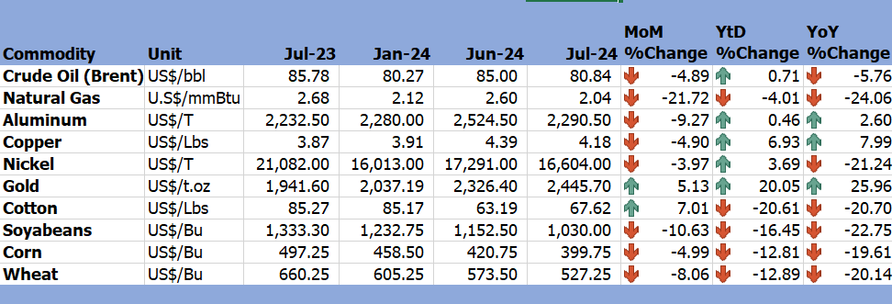

*Source: Trading Economics (2024)*

# 3.0 Zimbabwe GDP Growth Update

3.1 Economic growth in Zimbabwe is now projected to grow by 2% in 2024, 1.5% lower than the 2024 National Budget growth projections, on account of the El-Nino induced drought (2024 Mid-Term Budget and Economic Review).

Figure 1: Zimbabwe Economic Growth Prospects

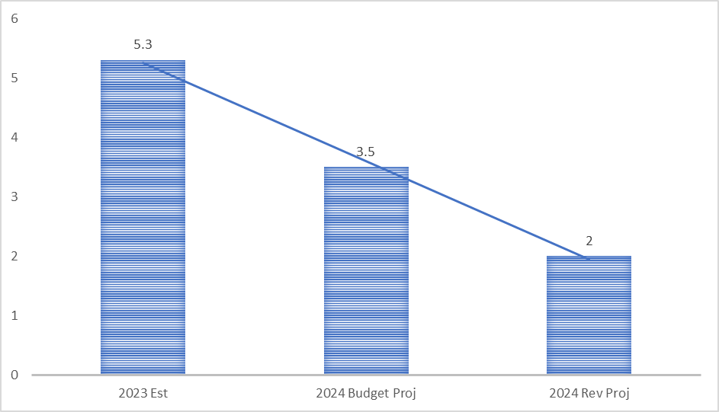

*Source: MoFED&IP (2024)*

3.2 The downward review is also attributed to low international commodity prices (including softening demand of mineral commodities especially by China, the major consumer) and depressed global economic activity.

# 4.0 Merchandise Trade Developments

4.1 According to the 2024 Mid-Term Budget and Economic Review, the country recorded a current account surplus of US$19.2 million in the first half of 2024 compared to a deficit of US$13.8 million recorded during the same period in 2023. The surplus is mainly attributed to an improvement of foreign currency receipts which increased by 9.5% to US$6.2 billion during the first half of 2024 up from US$ 5.6 billion recorded in 2023. Foreign currency receipts were largely driven by the growth in export receipts, mainly from gold, agriculture commodities and manufactured products, as well as diaspora remittances. However, by year end, the current account surplus is projected to narrow to US$44.5 million in 2024, relative to a surplus of US$133.9 million registered in 2023.

# 5.0 Exchange Rate Developments

## **5.1 Zimbabwean Dollar Exchange Rate Developments**

5.1.1 The Zimbabwean Gold (ZiG) depreciated against all major currencies as shown in Table 3. On a MoM basis, the ZiG lost by 0.6%, 2.26%, 1.83% and 1.59% against the USD, GBP, EUR and ZAR, respectively. The ZiG also lost value against the USD, GBP, EUR and ZAR both on YtD and YoY basis (see Table 3).

Table 3: ZiG Exchange Rate Movements – Month Ending 31 July 2024

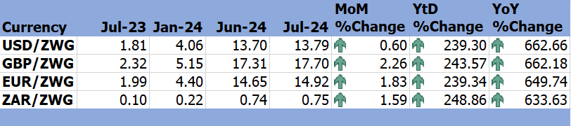

*Source: Reserve Bank of Zimbabwe (2024)*

## **5.2 Cross Rate Developments**

5.2.1 On MoM basis, the USD lost against the GBP, EUR and ZAR by 1.62%, 1.21% and 0.98% respectively, and the USD also depreciated against the GBP, EUR and ZAR on a YtD basis. However, on a YoY basis, the USD gained against the GBP, EUR and ZAR by 0.06%, 1.72% and 3.69%, respectively (see Table 4).

5.2.2 The trend inhibited by the USD is mainly attributed to the upcoming USA 2024 elections which tends to weaken the USD. Youness (2022), stated that with the increase in political tensions, convulsive rhetoric and negative political events such as the resignation of the government or political disputes, deteriorates exchange rate, meaning exchange rate depends mainly on the political atmosphere.

Table 4: USD Exchange Rate Movements – Month Ended 31 July 2024

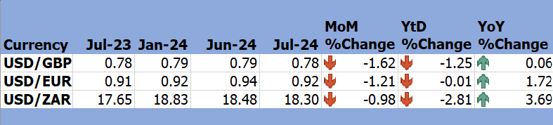

*Source: RBZ (2024)*

# 6.0 Inflation Developments

6.1 In July 2024, the economy continued on a deflation path, MoM inflation stood at -0.1% up from -0.2% recorded in June 2024, see Figure 2.

**Figure 2: Month-on-Month Inflation Outturn**

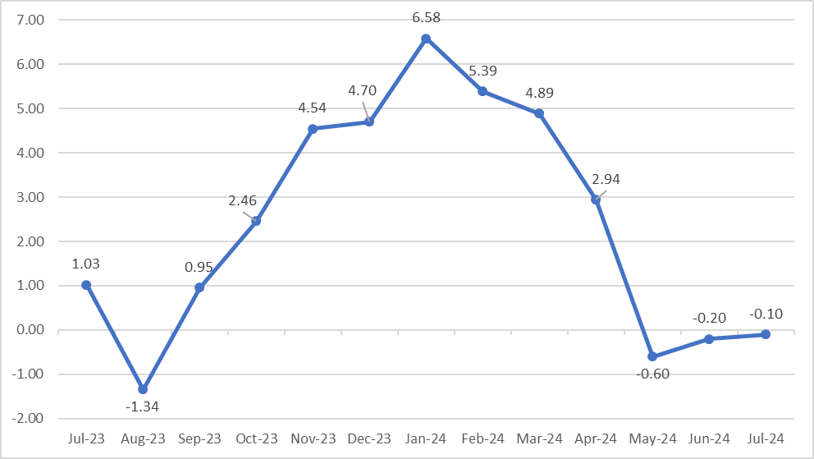

*Source: ZimStat (2024)*

6.2 Table 5 depicts the drivers of inflation in July 2024. The main contributors to inflation are food and non-alcoholic beverages and housing, water, electricity, gas and other fuels with weights of 31.3 and 27.62 respectively.

Table 5: Monthly Inflation for July 2024

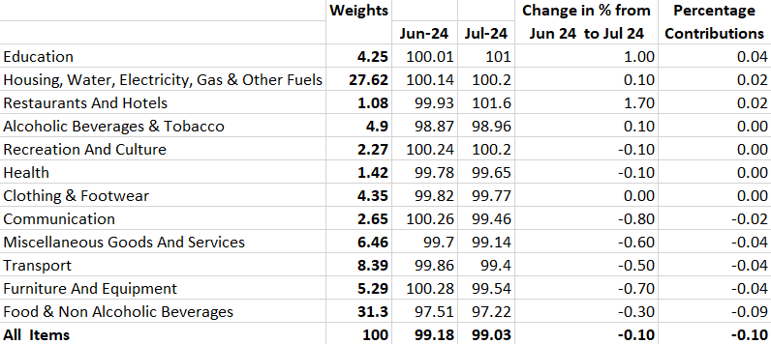

*Source: ZimStat (2024)*

# Monetary Developments

## **7.1 Money Supply and Interest Rates**

7.1.1 According to the RBZ (2024), broad money stock stood at ZWG41 billion at the end of May 2024 as shown in Figure 3. Broad money supply was made up of 80.4% foreign currency deposits and 19.6% local currency component. Money supply grew by 5.86% from ZWG38.75 billion in April 20224 to ZWG41.03 May 2024 in May 2024.

Figure 3**: Broad Money (M3) Supply**

*Source: RBZ (2024)*

7.1.2 According to the RBZ (2024), as of 26 July 2024, the average commercial bank deposit rates for ZiG range from 3.75% to 3.88% while for USD range from 1.53% to 1.86%. Commercial bank weighted lending rate (ZiG) for individuals ranged from 24.69% to 30.62% and for corporates from 24.44% to 32.21% while USD rates for individuals ranged between 11.03% and 15.19% and for corporates ranged from 9.59% to 15.42%.

# 8.0 Stock Market Developments

## **8.1 Zimbabwe Stock Exchange**

8.1.1 During the month under review, the Zimbabwe Stock Exchange recoded a bullish trend. On a MoM basis, All-Share Index gained by 92.95%, Top 10 Index gained 53.65%, market capitalization gained by 57.34% while Value Traded lost by 7.97% as shown in Table 6.

8.1.2 On a YtD Top 10 Index and market capitalization gained by 117.76% and 254.29% respectively while All-Share Index lost by 7.66% and value traded lost 15.95%. All-Share Index, Top 10 Index, Value Traded, and market capitalisation gained on a YoY basis.

Table 6: Zimbabwe Stock Exchange Movements

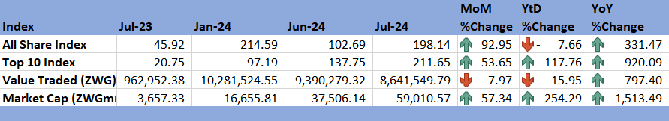

*Source: ZSE (2024)*

## **8.2 Victoria Falls Stock Exchange**

8.2.1 The Victoria Falls Stock Exchange recorded a bullish trend in July 2024. On MoM basis, the All-Share Index, Value Traded and market capitalization gained by 2.25%, 317.07% and 3.21% respectively. Market capitalization increased by 3.21% in July 2024 to reach USD1007.22 million up from USD975.87 million (see Table 7).

8.2.2 On a YtD basis, the All-Share Index and market capitalization gained 2.42% and 3.02% respectively, while Value Traded lost by 11.36% and 0.19%. All-Share Index, Value Traded and market capitalization gained by 53.71%, 440.29% and 11.58% respectively, on a YoY basis.

Table 7: Victoria Falls Stock Exchange Movements

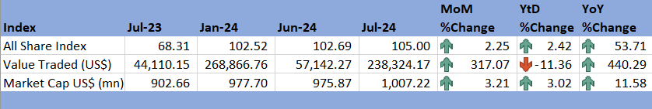

*Source: VFEX (2024)*

# 9.0 Recommendations

9.1 The following recommendations are being proposed:

9.1.1 **Mitigation of El Niño Effects**: The projected economic slowdown in 2024, partly attributed to the El Niño-induced drought, underscores the need for proactive measures. The country should enhance its climate resilience by investing in drought-resistant crops, improving irrigation infrastructure, and adopting climate-smart agricultural practices. Government support for smallholder farmers through subsidies and training programs can also help mitigate the impact on food security and economic growth.

9.1.2 **Diversification of Exports**: The country’s reliance on commodity exports, particularly minerals and agriculture, makes the economy vulnerable to global price fluctuations. To cushion against low international commodity prices, the country should focus on diversifying its export base. This could involve promoting value addition and processing industries, particularly in agriculture, minerals, and manufacturing, to increase export earnings and reduce dependence on raw commodity exports.

9.1.3 **Managing Inflation and Exchange Rate Stability**: The economy’s ongoing deflationary trend requires careful management to avoid deflationary pressures that could hinder growth. The RBZ should aim for price stability by maintaining a balanced approach to money supply and interest rate policies. Additionally, efforts to stabilize the ZiG through sound fiscal and monetary policies will be crucial in curbing currency depreciation and supporting economic stability.

9.1.4 **Leveraging Diaspora Remittances**: Diaspora remittances are a key driver of foreign currency receipts and can be further leveraged for economic development. The government should create investment channels that encourage the diaspora community to invest in national projects, infrastructure, and business ventures. Policies to reduce remittance costs and streamline transfer processes can also maximize the impact of these inflows.

9.1.5 **Capital Market Development**: The strong performance of the Zimbabwe Stock Exchange and the Victoria Falls Stock Exchange presents an opportunity to further deepen the capital markets. The government should promote the listing of more companies and provide incentives for foreign and local investors to participate in the markets. Enhancing transparency, regulatory frameworks, and investor protection will also build confidence in the markets.

9.1.6 **Strengthening Trade Relations**: The country should capitalize on regional and international trade opportunities by actively engaging in trade agreements that open up new markets for its goods and services. Strengthening relations with key trading partners, especially within the Southern African Development Community (SADC) and the African Continental Free Trade Area (AfCFTA), will help drive export growth and integration into global value chains.

# 10.0 References

IMF. (2024). *World Economic Outlook July 2024.* International Monetary Fund.

MoFED&IP. (2024). *2024 Mid-Term Budget and Economic Review.* Ministry of Finance, Economic Development and Investment Promotion.

RBZ. (2024). *Exchange Rates*. Retrieved from Reserve Bank of Zimbabwe: https://www.rbz.co.zw/index.php/research/markets/exchange-rates

Reserve Bank of Zimbabwe. (2024). *Publications*. Retrieved from Reserve bank of Zimbabwe: https://www.rbz.co.zw/index.php/publications-notices/publications/weekly-economic-review

Trading Economics. (2024). *Commodities*. Retrieved from Trading Economics: https://tradingeconomics.com/commodity/crude-oil

VFEX. (2024). *Main Dashboard*. Retrieved from Victoria Falls Stock Exchange: https://www.vfex.exchange/

World Bank. (2024). *Global Monthly Overview July 2024.* The World Bank Group.

World Economic Forum. (2014). *Commodity Prices*. Retrieved from World Economic Forum: https://www.weforum.org/agenda/2014/12/why-are-commodity-prices-falling/

Youness, M. (2022). The Impact of Political Uncertainty on Currency Exchange Rate. *Technium Social Science Journal. Vol 28 414-424*.

ZimStat. (2024). *Inflation Rates*. Retrieved from Zimbabwe Statistics Agency: https://www.zimstat.co.zw/

ZSE. (2024). *Main Dashboard*. Retrieved from Zimbabwe Stock Exchange: https://www.zse.co.zw/

**NECF Secretariat, 2024**